Exploring Lang Chain
LangChain JavaScript integrations - Docs by LangChain
A provider is a third-party service or platform that LangChain integrates with to access AI capabilities like chat models, embeddings, and vector stores.
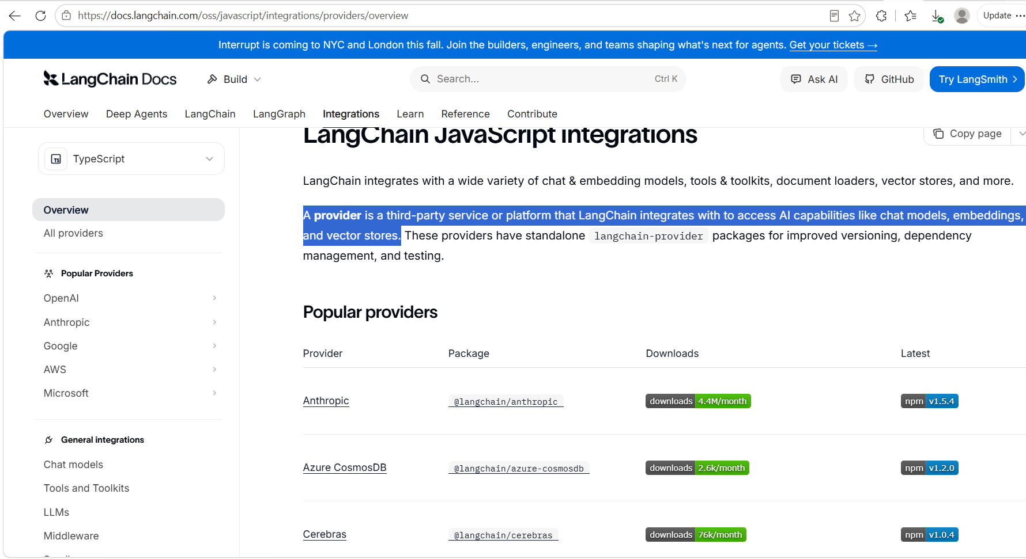

Enhancing the Project

Added Finance in the Drop Down
Manually Added
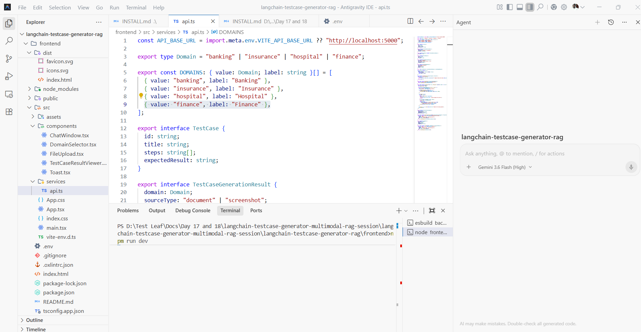

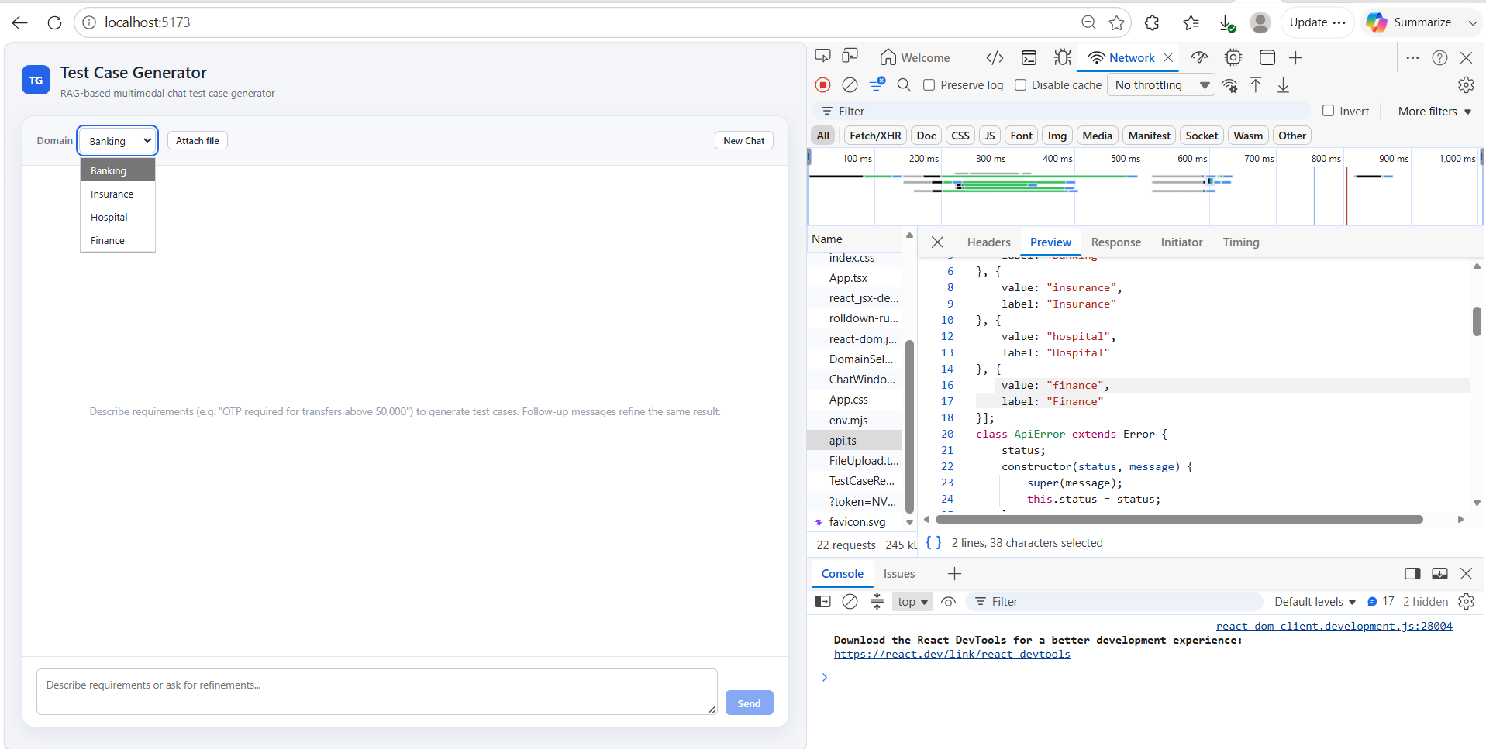

Added Text Format – Using Vibe Coding Added the Text.
